**Java Login & DB 연동**

[결과]

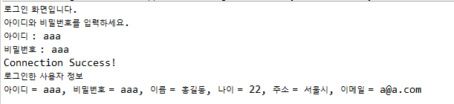

[DataBase]

- 계정명: javacon

- 조건 : DataSource Explorer를 통한 실행

|  |
| --- |
| **CREATE** **TABLE** member (    );  **INSERT** **INTO** member VAlUES('aaa','aaa','홍길동',22,'서울시','a@a.com');  **INSERT** **INTO** member VAlUES('bbb','bbb','알파고',21,'제주시','b@b.com');  **INSERT** **INTO** member VAlUES('ccc','ccc','베타고',22,'광주시','c@c.com');  **INSERT** **INTO** member VAlUES('ddd','ddd','감마고',22,'울산시','d@d.com');  **INSERT** **INTO** member VAlUES('eee','eee','세타고',22,'이리시','e@e.com'); |

|  |
| --- |
| **public** **class** User {  **private** String id;  **private** String passwd;  **private** String name;  **private** **int** age;  **private** String addr;  **private** String email;  } |

|  |
| --- |
| **import** java.sql.Connection;  **import** java.sql.DriverManager;  **import** java.sql.ResultSet;  **import** java.sql.SQLException;  **import** java.sql.Statement;  **public** **class** LoginSVC {  Connection con;  **static**{    }  **public** **void** connect(){    }  **public** User login(String id, String passwd) {      }  } |

|  |
| --- |
| **import** java.util.Scanner;  **public** **class** LoginMain {  **public** **static** **void** main(String[] args) {    **do**{  System.***out***.println("로그인 화면입니다.");  System.***out***.println("아이디와 비밀번호를 입력하세요.");  System.***out***.print("아이디 : ");  System.***out***.print("비밀번호 : ");    **if**(user == **null**){  System.***out***.println("아이디나 비밀번호가 일치하지 않습니다.");  }  **else**{  System.***out***.println("로그인한 사용자 정보");  System.***out***.println(user);  }  }  **while**(!isStop);  sc.close();  }  } |